Access to Online Resources for Collections and Holt Math
Your student (6th, 7th, or 8th grader) can access his/her language arts textbook (Collections) and Math textbook (Holt) from home!
1. Launch your browser (IE, Safari, Chrome, Firefox)
2. Navigate to moodle.cksd.wednet.edu (no “www”)
3. Your student will need to log in to Moodle using their regular computer login username and password
4. Click the link in the Resources grid:
5. You will see this screen:
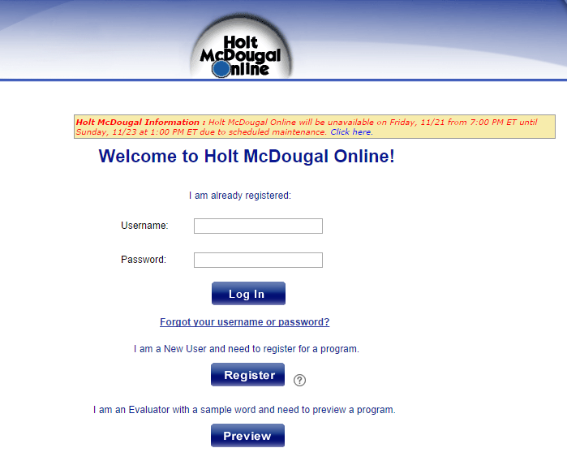
Username is the same that they use to login to CKSD computers. Password is the full 8-digit student ID #. Students should know this number, but if not, you can contact your student’s teacher.

6. Once logged in, you will see this dashboard:
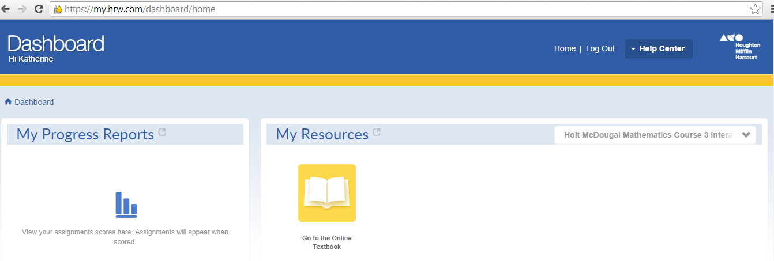
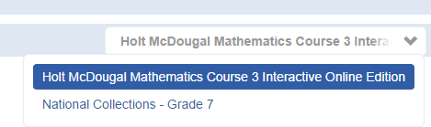
Use the drop-down menu to select Holt Math text or Collections text.

7. For Math: choose “go to online textbook” icon, then use the drop-down menus to
select a chapter and lesson.
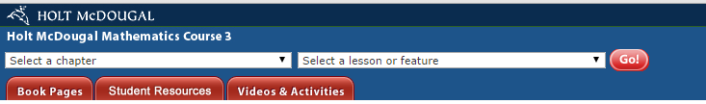
8. For Collections: most of the time they will choose the Student eBook
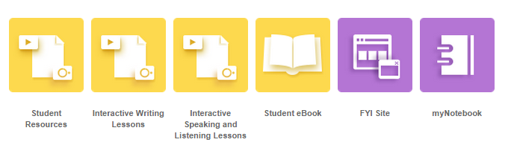
Choose the Contents icon in the upper left corner to navigate to the unit and lesson
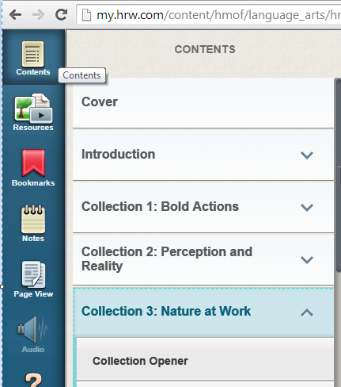
Page View allows the reader to choose from scroll, one page, or two page view, as well as change font size.
