Managing Students in a class in ThinkCentral
(There is also a video of these steps: Please copy the link below and open in CHROME – it’s a Quicktime video. If you just click the link, you won’t see the whole screen or have the ability to pause, play, etc.)
http://staff.cksd.wednet.edu/curriculum/literacy/Shared%20Documents/Houghton%20Mifflin%20Journeys/ThinkCentral%20ManagingClassRoster.mp4 (Video courtesy of Michelle Morrow – thanks Michelle!)
- Login to Thinkcentral (use Chrome!)
- In the upper right of the Dashboard, choose SETTINGS
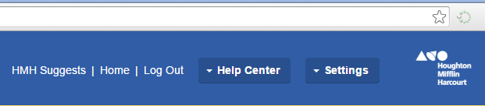
- On the drop down menu choose MANAGE CLASSES
- The Manage Classes screen will open. (see sample below)
Select your class, and click EDIT CLASS
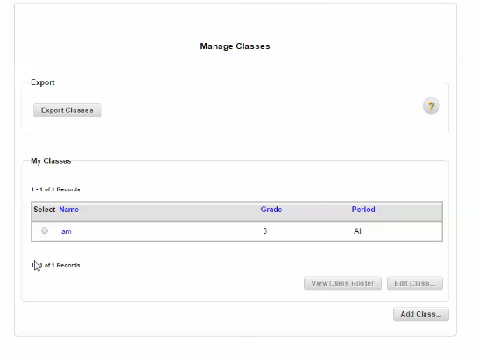

- You’ll get another screen – with choices of which products to have available to kids in your class.
At the bottom, choose ASSIGN STUDENTS
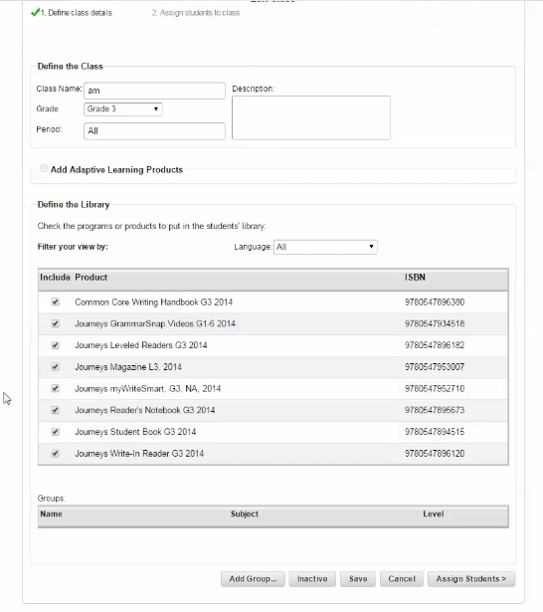

- Edit Class: You will see a list of all students in your grade level. Select your students and add them to your roster. You likely already have kids here – just check through and add who might be missing.
If you have a kid move, this is where you will need to remove him or her from your roster so that he/she can be added to a class at another site.
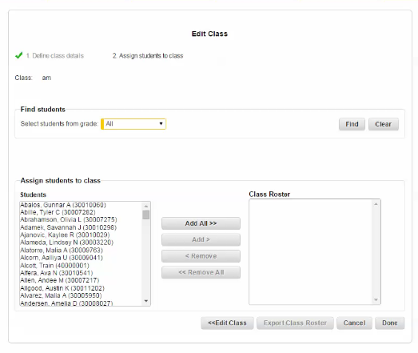
- When finished, click DONE
- Your class roster should now be complete.
DO NOT CREATE STUDENT ACCOUNTS! STUDENTS ARE ADDED via POWERSCHOOL UPLOAD.
-------------------------------------------------------------------------------------------------------------------------------
Kids can access ThinkCentral via Moodle – the problem is that right now, it opens in IE instead of Chrome.
To avoid a lot of errors, I am sending BTCs the instructions to create a CHROME link to ThinkCentral student login on the student desktop.
https://www-k6.thinkcentral.com/ePC/start.do?orgID=03241904
This is the link that needs to open in CHROME. You can put it on your moodle site – but be sure to note that they need to use CHROME or FireFox as their browser at home.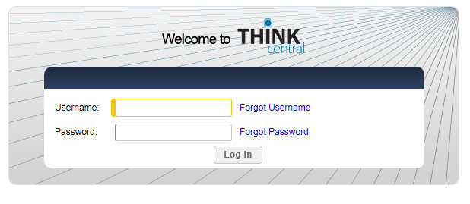
Login and password are the same standard CK logins that kids use to access computers.

Kids can access access ThinkCentral via Moodle.
Problem right now is that it opens in Internet Explorer – this might mean a lot of problems if running in this browser.
--------------------------------------------------------------------------
Have them login to Moodle, and choose the ThinkCentral link on their Resources Menu
It will ask them to login to ThinkCentral

