Creating a Basic Moodle Presence
Step-by-Step Instructions

Table of Contents
Accessing Moodle 1
Adding Text to Your Moodle Site 2
Summary Area 2
Labels 3
Webpage 4
Upload a File 4
Add Additional Content Areas (Topic/Weeks) 6
Add, Move, Remove, and Dock Blocks 6
Events and Calendars 8
Add the Calendar Block 8
Add a New Event 8
Edit or Delete an Event 8
Link to a Website 9
Add a Folder 9
Work with Images 10
Accessing Clip Art 11
Glossary 12

Accessing Moodle

Logging in to Moodle
From School
- From your Start menu, select My Moodle.
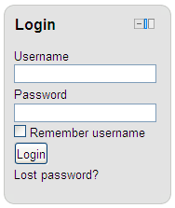
- You will be directed to your My Moodle page.

From Home
- Open your browser (Internet Explorer, Firefox, Chrome, etc.).
- In the address bar, type:
http://moodle.cksd.wednet.edu
- Hit the Enter key on your keyboard or the Go button in your browser.
- At the Moodle screen, type your Central Kitsap School District network login name and password.
Enter Your CKSD Login Name and Password.
- Click the Login button.
- You will be directed to your My Moodle page.

Navigation in Moodle
The Moodle theme has three navigation options.
1) The quick launch icons located on the top right of the screen takes you to the following:
My Moodle
School Web Site
CKSD Web Site
Digital Locker
Email (Webmail for staff, Gaggle for students)

2) A drop-down menu bar.
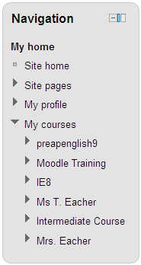

3) The Navigation Block – New 2.0 Feature

The new Navigation Block is located in the left-hand column. The navigation block appears on every page of the site. It contains an expanding tree menu which includes My Home, Site Pages, My Profile, and Courses. What appears in the navigation block depends on the role of the user, where they are in the Moodle site, and any settings that have been applied globally.
HINT: The Navigation Block is user aware and displays information about the person who is logged into Moodle. If a student is not enrolled in your class, do not direct them to the Navigation block as a way of finding your course. Direct them to use the drop-down menu instead.

To expand a section, click the link or arrow.

In the My Courses section, you will see your Moodle course name(s) listed.

To go DIRECTLY to your course, click on your course name.

To expand and navigate to a specific section in your course, click the arrow to expand the selection and then select a topic/week area or a resource.

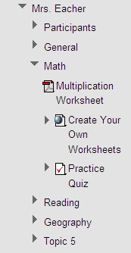
HINT: If you select a topic or week, Moodle will open your site and filter out the other topics/weeks. In the image below, Math was selected. Notice that the Math topic area is the only topic shown. To show all topics, click on the Show All Topics icon.
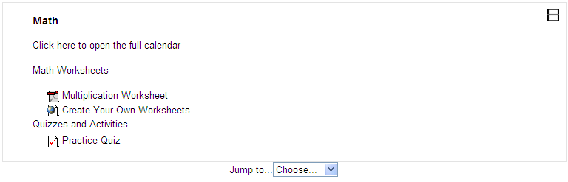
You can open other topics/weeks from the Jump to… menu.

A Topic/week will not appear in the Navigation block if it does not contain a resource or activity.

Adding Text to Your Moodle Site
There are several ways to post information to your Moodle site – through the summary area or label using a text editor, through a new Moodle page, or by uploading a file (PDF or Office document).

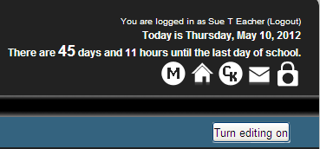
Summary Area

- Click the Turn editing on button
OR
From the Settings Block, click on the Turn editing on link.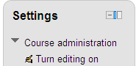
- In a contact area, select the Edit Summary icon.
- At the Summary screen, click in the text box and begin typing.
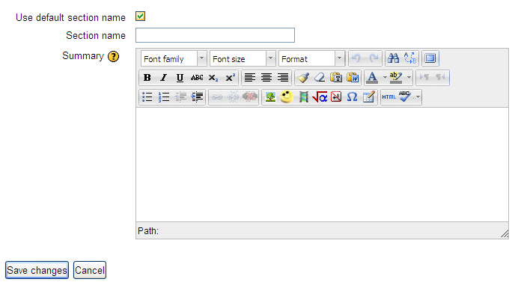
Example of a Summary.
New 2.0 Feature – Spell check.

Type in this space.

HINT: To expand the editor, click and drag the expand icon located in the lower right corner OR click on the Toggle Full Screen button located on the first toolbar.
To rename a topic, uncheck this box and type a new section name.
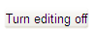
- When you finish creating your message, click the Save changes button.
- Click the Turn editing off button OR use the Turn editing off… link found in the Settings Block.

Labels
In addition to the summary area located at the top of a topic/week, text can be added to a Moodle page using the Label resource.

A label allows you to insert text in between resources and activities. The following image from the Moodle Training site shows a label inserted above the Programming - The New Literacy web link.
Label example

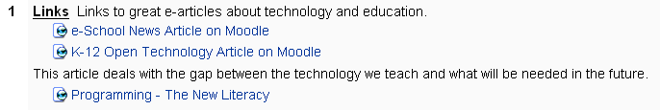
HINT: Use the right arrow to indent items.
To create a label:
- Click the Turn editing on button.
- In the content area where you want the link, select Label from the Add a resource… drop-down box.
- Type the text and when complete, click the Save and return to course button.
- To move the label to a new spot:
  - Click on the up and down arrow symbol.
  - The label disappears from the screen and boxes are placed in the available spots. Click the box closest to the spot where you want to put your label. 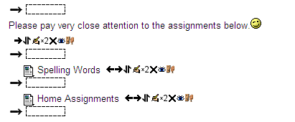
  - Your label will reappear in the space selected.

Webpage
This sort of resource makes it easy to develop a complete single web page within Moodle. This option works well if you want to add a large amount of text or images or if you change the information frequently. Unlike a Word document, the content of a webpage can be viewed by all users.

- Click the Turn editing on button.
- In the content area where you want the link, select Page from the Add a resource… drop-down box.
- From the General section, enter a name for the page. The name will be displayed in the content area as a hyperlink.
- If desired, enter a description.
HINT: Select the checkbox next to ‘Display description on course page’ to display the description just below the link title.
- In the Content section, type or copy and paste your text into the text editor.
HINT: If you paste text from Word, click on the Paste from Word icon located on the tool bar. Paste the text into the Paste from Word dialog box and then click the Insert button. Moodle will strip out Word’s non-compatible formatting code making it easier to format the text in Moodle.
- In the Options section, select ‘Display page name’ and/or ‘Display page description’ if you want the name and description to appear on the top of the webpage.
- Click the Save and return to course or Save and display button to save the page.

Upload a File
Although it is easy to generate content directly in Moodle through the text editor or webpage, almost any type of electronic file can be uploaded.
HINT: Not all students have Word, Excel, or PowerPoint on their home computer. Consider making the files into a PDF (Portable Document Format) and supplying a link to the free download of Adobe’s Acrobat Reader http://www.adobe.com/products/acrobat/readstep2.html.

Add a Document Link
- Click the Turn editing on button.
- In the content area where you want the link, select File from the Add a resource… drop-down box.
- On the Adding a new File page, enter a name for your document link and if desired, a brief description of the document. If you want the description to appear below the title, select the check box next to ‘Display description on course page’.
- In the Content section, click the Add.. button. The File picker screen opens.
- The File picker has four links on the left.
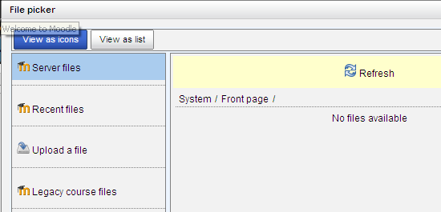
  - Server files
If you uploaded a file BEFORE the conversion to 2.0:
    - Click System.
    - Select your course category and then your school name. Example: a teacher at Brownsville will select Elementary Schools, Brownsville, and then Find Your Teacher.
New to 2.0
    - Select Legacy course files.
- Recent files
If you recently uploaded a file through another resource or activity, click Recent files. Recent files will show the last 50 files uploaded after the 2.0 upgrade.
- Upload a file
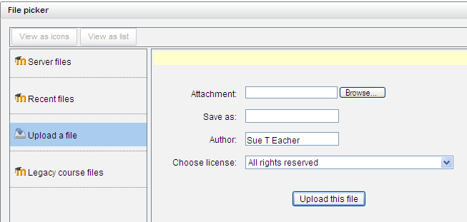
If you want to upload a file from your computer:
- Click Upload a file.
- Click the Browse button.
- My Computer opens; use the Look in: drop-down or the My Documents button to find your file.
- Double-click the file name. My Computer closes and you are back at the File picker screen.
- If you want to rename the file, enter a new name in ‘Save as:’.
Note: Your name is entered as the author and the license option of ‘All rights reserved’ is selected. If the file was not created by you, please give credit to the author. If you want to change the copyright setting for the file, select a different license option from the drop-down menu. (See the Glossary for the definitions.)
- Click the Upload this file button.
- In the Options section, select the Display option. (See the Glossary for the definitions.)
- If you opt to open the file inside of a Moodle screen and you want the resource name and description to appear, select the check boxes next to ‘Display resource name’ and ‘Display resource description’.
- Click the Save and return to course or Save and display button to save your changes.
- Legacy course files is not working – use Server Files instead.

Add Additional Content Areas (Topic/Weeks)

By default, a Moodle site has two Topics or Weeks (0 & 1). To add or decrease this number, open the Edit Setting link located in the Course Administration section of the Settings Block.
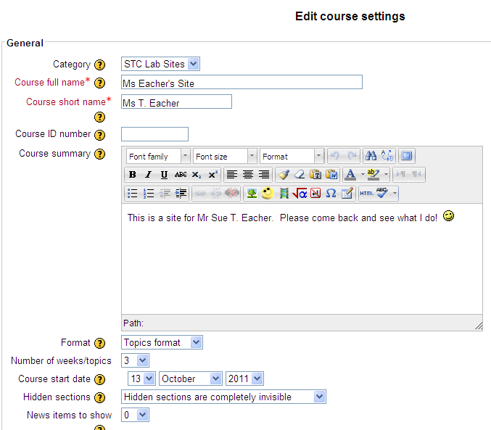
Change your course name – the short name has to be unique.
If desired, change from Topic format to a Weekly format.
Increase or decrease the number of topics/weeks.
New to 2.2
A Moodle site can now contain one topic or week. Change the Number of weeks/topics to 0.

Topics/Weeks are removed from the bottom and if it contains activities, the activities will appear in an ‘Orphaned Activities’ box that only the teacher sees when editing is turned on.

The content of the topic/week is not deleted. Increase the number of weeks/topics to restore the content.
IMPORTANT
In order to save your changes, click the Save Changes button at the bottom of the screen.

Add, Move, Remove, and Dock Blocks
Add, move, remove, or dock a block to customize the look of your Moodle page. Blocks are located on the right and left side of the screen or they can be docked on the left border. The Navigation and Settings blocks are ‘locked’ and cannot be deleted.

Add a Block – When editing is turned on, Add a block appears at the bottom of the right column. All of the unused blocks appear in the drop-down list. Select the block from the list and then use the double arrows to move it to the desired location.

Move a Block – New Feature in 2.0 – The Move icon (double arrow) moves the block to another location. Click the move icon to show the ‘move here’ boxes. Click the box closest to your desired location.
If you wish to cancel the move, look for ‘Moving this block (Cancel)’ found under the block being relocated. Click Cancel.

Remove a Block - To remove unused blocks, click the Turn editing on button and then click the black X. The block is placed in the unused block list found in Add a block.

Dock a Block – New Feature in 2.0 – Except for the Course/Site Description block, blocks can be ‘docked’ or collapsed. Once docked, Moodle will remember your settings and continue to dock the block until you ‘undock’ it. Only your view will be affected and you cannot dock a block for all users.

To dock a block, click on the dock icon located in the upper right corner of the block. It is the blue bar located to the right of the Hide icon.
When a dock is blocked, only the name of the block appears. Mouse-hover over the name to access the contents of the block.

To ‘undock’ a block, click the blue box located in the upper right corner of the expanded content.

To undock all blocks, click the blue box located at the bottom of the ‘tab.’

.
HINT: The docked area will only hold a limited number of blocks and does not provide for a way to scroll to the blocks off the screen.

The docked blocks are in a fixed location and will follow you as you scroll down the Moodle page.

Events and Calendars

Add the Calendar Block
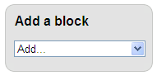
- Click the Turn Editing On button.
- The Add a block appears in the lower right-hand column. Click the drop-down arrow in the Add… field.
- From the subsequent list, select Calendar.
- The Calendar is added to the bottom of the column. Use the Move icon to move the block to the desired location.
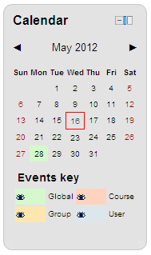
The Calendar is color-coded. The current day is shown outlined in red. The Course events like assignments, quizzes, etc. are shown in pink. Global events added by the system administrator, group events, and user events all have different colors.

Multiple-day events are shown with the first day in a solid color and the subsequent days with lines.
HINT: You must enter an end time to the end date in order for the date to appear on the last day.

Hover the mouse pointer over a date to display a pop-up window that shows any events scheduled for that day.

Use the eyes in the Events key to filter out events. Example: Closing the eye next to Global will hide all global events on YOUR calendar view. These settings do not affect what other users see.

Add a New Event
Including a date on an assignment, quiz or workshop, automatically adds the date to the calendar. Other events are added using New Event.

- If the Upcoming Events block is visible, click the New Event… link to open the New Event window. OR
From the Calendar block, click the Month/Year to open the Calendar. In the right corner, click the New Event button.
- In the type of event drop-down menu, select a Course.
- Enter a name and if desired, a brief description for the event.
- Enter the event’s date and if it isn’t an all-day event, the time.
- If the event has a different end date or time, uncheck the radio button next to ‘without duration’ and complete the ‘Until’ section.
- If the event occurs weekly, enter how many weeks the event will repeat.
- Click the Save changes button to return to the Calendar window. The new event will appear on your calendar.

Edit or Delete an Event
- From the Calendar or from the Upcoming events block, click on the event.
- At the bottom of the event description box, click the edit icon to edit the event or the delete icon X to delete the event.

Link to a Website

- Click the Turn editing on button.
- In the content area where you want the link, select URL from the Add a resource… drop-down box.
HINT: The keyboard shortcut for copy is Ctrl C and paste is Ctrl V.
- On the Adding a New Url page, enter a name for the link and if desired, a brief description of the website. Note: Select the checkbox next to ‘Display description on the course page’ if you want the description to appear below the link.
- In the Content section, either type or copy and paste the web address in the External URL text box.
- In the Options section, select how you want the page to open in the Display drop-down menu. (See the Glossary for the definitions.) .
- Click the ‘Save and return to course’ or the ‘Save and display’ button to save your changes.

Add a Folder
This option allows you to display links to files or photos on another Moodle page. For example, if you have ten documents that a student needs to read for a project, create the folder resource and upload all of the documents to the folder. On the main Moodle page, the student will see one link and when selected, be taken to another page that contains all of the resources needed to complete the project.
- Click the Turn editing on button.
- In the content area where you want the link, select Folder from the Add a resource… drop-down box.
- Type a name for the folder link. This is the name the student will click to open the folder.
- If desired, type a description of the folder’s content. Note: Select the checkbox next to ‘Display description on the course page’ if you want the description to appear below the link.
- In the Content section, click the Create folder button. Enter the folder name and then click the OK button.
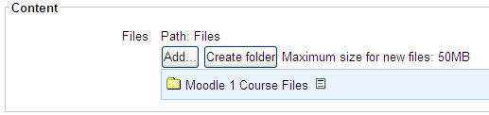
- Click on the folder name to open it.
- Click on the Add.. button to open the File Picker.
HINT: Notice the path above the Add… button changes. To navigate out of the folder, click on Files.

- To upload a new document/image, click on the Upload a file button.
- Click the Browse… button.
- Use My Computer to browse to the document/image.
- Double click on the file.
- If desired, rename the file in the Save as: field; enter a different author’s name, or change the license option.
- Click the Upload this file button.
- Continue steps 8 – 14 until all of the files are uploaded to Moodle.
- Click the ‘Save and return to course’ or the ‘Save and display’ button to save your changes.

Work with Images
To add an image to your site, you must first upload the file. For the best results, do not copy and paste an image from a document. Please observe the copyright rules when using a graphic or photo.
HINT: The text editor is available on many Moodle Resources and Activities. Images can be added any time a text editor is visible.
- Click the Turn editing on button. To add an image to a summary, click on the edit icon.
- Place your cursor in the text editor and use the picture icon from the toolbar to insert an image.
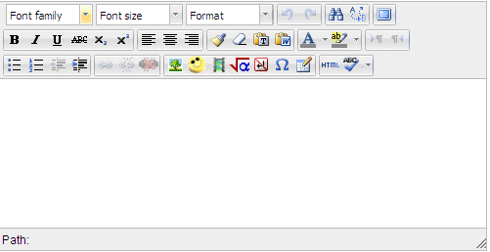
- Click the Find or upload an image… button.
- From the File picker screen, click on the Upload a file button. (To add clip art, see Accessing Clip Art.)
HINT: To expand the editor, click and drag the expand icon located in the lower right corner OR click on the Toggle Full Screen button located on the first toolbar.
- Click the Browse… button.
- Use My Computer to browse to the image.
- Double click on the file.
- Click the Upload this file button.
- From the Insert/edit image screen, add alternate text and check the preview.
New to 2.0
The Alignment drop-down box will set how the text aligns with the image. The preview image on the right changes to show you how it will look on the Moodle page.

Change the size of the image from Dimensions.

Vertical and Horizontal space will add additional space around the outside edges of the image.

Border will put a black border around the outside of the image.

As you add options, Moodle writes the code in the Style field.
- If you want to edit the image, click on the Appearance tab.

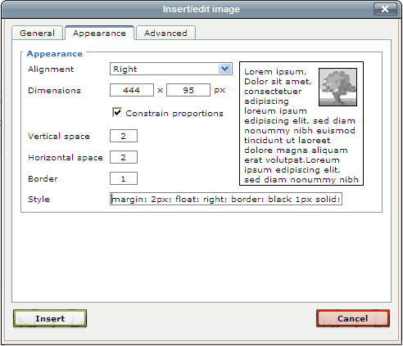
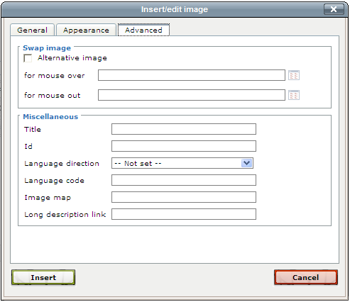
- For more options, click the Advanced tab.
New to 2.0

Swap image - To provide a mouse over effect (the image changes when you move the mouse over the picture), select the check box next to Alternative image. Select the image to use for the mouse over and mouse out.

Miscellaneous - Optional
- Click the Insert button.
- Click the Save changes button.

Accessing Clip Art
Microsoft Office download center provides thousands of images that are copyright free. To use one of these images in Moodle:
- In Moodle, first place your cursor where you’d like the image to be pasted.
- Open the edit summary icon:

- Click the insert image icon:

- Upload a File, browse to C:\Program Files\Microsoft Office\MEDIA\CAGCAT10
- Click on the viewer in the upper right and click “Thumbnails” 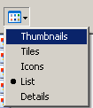
in order to view the clipart images.
- Choose the image you want and then click OPEN, then Upload this File. Type a brief image description, then click INSERT.

New to 2.0 – Moodle now accepts .wmf images (windows metafile). All images located in Microsoft Clip Art gallery are compatible with Moodle 2.0.

Glossary
All rights reserved: A phrase that originated in copyright law as part of copyright notices. It indicates that the copyright holder reserves, or holds for their own use, all the rights provided by copyright law, such as distribution, performance, and creation of derivative works; that is, they have not waived any such right.

Public Domain: The work may be freely reproduced, distributed, transmitted, used, modified, built upon, or otherwise exploited by anyone for any purpose, commercial or non-commercial, and in any way, including by methods that have not yet been invented or conceived.

Creative Commons: The work is free to share, adapt or use for commercial use as long as you attribute the work in the manner specified by the author or licensor.

Creative Commons - NoDerivs: The work is free to share and for commercial use as long as you attribute the work in the manner specified by the author or licensor and you do not alter, transform, or build upon the work.

Creative Commons – No Commercial NoDerivs – The work is free to share as long as you attribute the work in the manner specified by the author or licensor, you do not alter, transform, or build upon the work, and it isn’t used for commercial purposes.

Creative Commons – No Commercial - The work is free to share and adapt as long as you attribute the work in the manner specified by the author or licensor and it isn’t used for commercial purposes.

Creative Commons – No Commercial Share Alike - The work is free to share and adapt as long as you attribute the work in the manner specified by the author or licensor, it isn’t used for commercial purposes, and if you alter the work, you may distribute the resulting work only under the same or similar license.

Creative Commons – Share Alike - The work is free to share, adapt, and use commercially as long as you attribute the work in the manner specified by the author or licensor and if you alter the work, you may distribute the resulting work only under the same or similar license.

Display Options
This setting, together with the file type and whether the browser allows embedding, determines how the file is displayed. Options may include:

Automatic - The best display option for the file type is selected automatically.

Embed - The file is displayed within the page below the navigation bar together with the file description and any blocks.

Force download - The user is prompted to download the file.

Open - Only the file is displayed in the browser window.

In pop-up - The file is displayed in a new browser window without menus or an address bar.

In frame - The file is displayed within a frame below the navigation bar and file description.

New window - The file is displayed in a new browser window with menus and an address bar.

