Citation Lists with Easy-Bib name _______________
- Login to Moodle

- Choose EasyBib from the resource links
You will need to enroll the first time.
Click on the blue link

- EasyBib will open! Click on New Project to get started

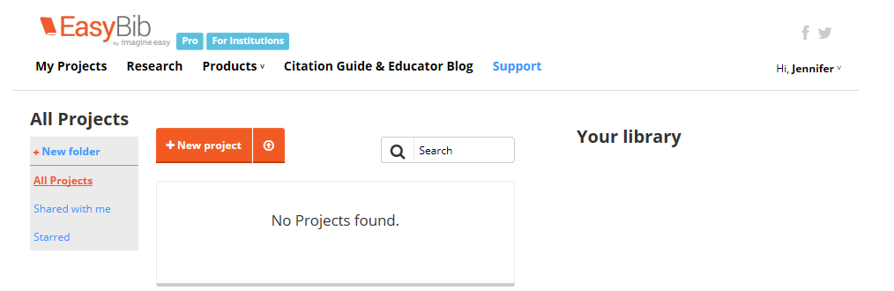

- Name your project, Keep MLA style, then click Create
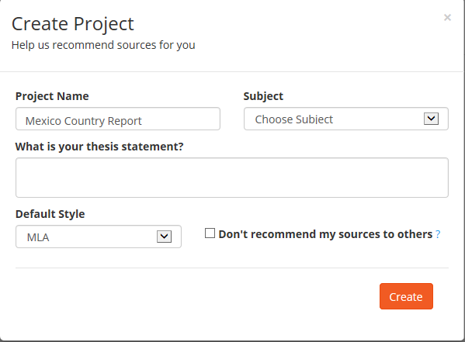

- When you are back to this screen:
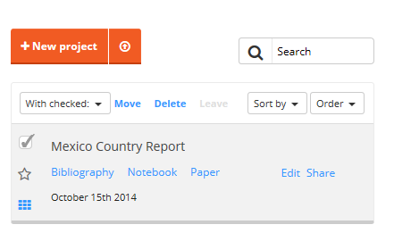
Click on Bibliography to start citing your sources!
Check the box next to the project you started:
- FOR A WEBSITE: open a new tab and locate the website that you want to cite.
- Highlight the URL and copy (Ctrl-C)

- Go back to Easy Bib and paste (Ctrl-V) your URL into the text box
Click “Cite It”
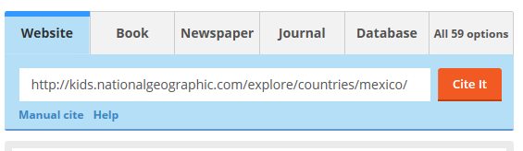

- You will get a message of what Easy Bib found. If OK – click continue
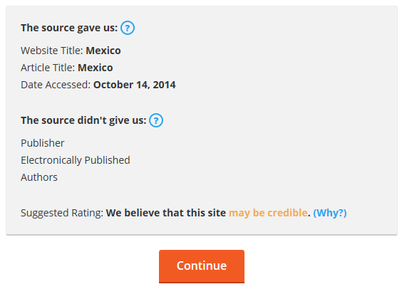

- Here is where you can edit/add the citation before finalizing.

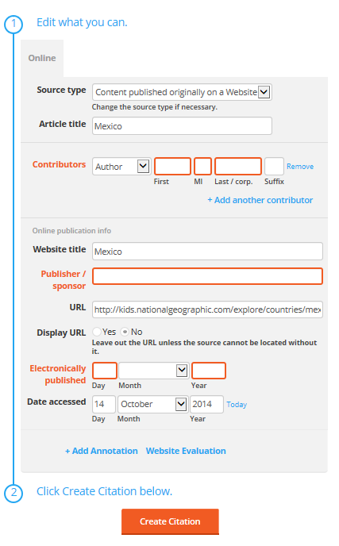
You can leave the title, even if it’s long!
Did you find any contributing authors that Easy Bib may have missed?
Click YES – you DO need the URL in your citation.
This will always have the current date. If you visited this site earlier, then you need to change the date here.
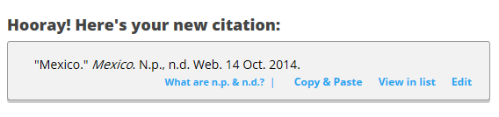
This citation is now saved in your project.
- For a BOOK – look back at step 8 – instead of the website tab, choose BOOK. Enter the title and author and it will likely find the rest!

